Y2Q1W3

Mephibosheth
Ask: Do you remember who Jonathan was?
Ask: Do you remember how David thought about Jonathan?
Say: David and Jonathan had promised to be friends forever.

Ask: Let's say that I am your friend. If my mother or brother visited, would you be friendly to them?

Bible Story

Ask: Can God lie?
Ask: If God says that something will happen, will it happen?
Sing Songs

Return to tables
Memory Verse: Fill in the blanks and then say the memory verse on the colouring page.

Say: Every week this term we will be making a page to add to a scrapbook.
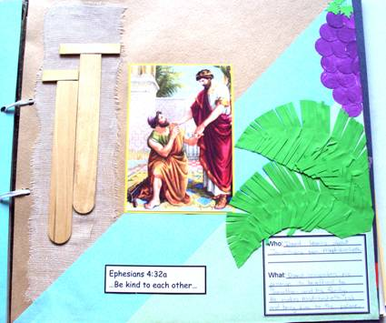
Craft:
- Choose a coloured cardboard
- (Optional) Add blue or green to the bottom corner
- Cut the sides of the palm leaves and bend them before sticking them to the page.
- Use the purple spots to make a bunch of grapes
- Glue a piece of bandage and then tape the paddle pop "crutches" on top.
- Add the Bible Verse and Who/What card.

Discuss the following depending on age, interest and time:
How do you treat people you don't know? How should you?
How do you treat your friends?
Could you be a better friend? How?
What can you do to make new friends?
What can we do to welcome new people?

Ask: What can we do to become better friends?
Say: It's nice to be able to do fun things with your friends, and it can be even better if you have photo's so you can look at them later and remember.
Look: At some photos of things we have done as a Church group.
Take: A group photo; take individual photos to go on books.

Finish with prayer at each table.

